Aim
To categorize and prioritize platform requirements.
Procedure
- Create Jira backlog.
- Add all 6 features.
- Categorize using MoSCoW.
- Classify using Kano.
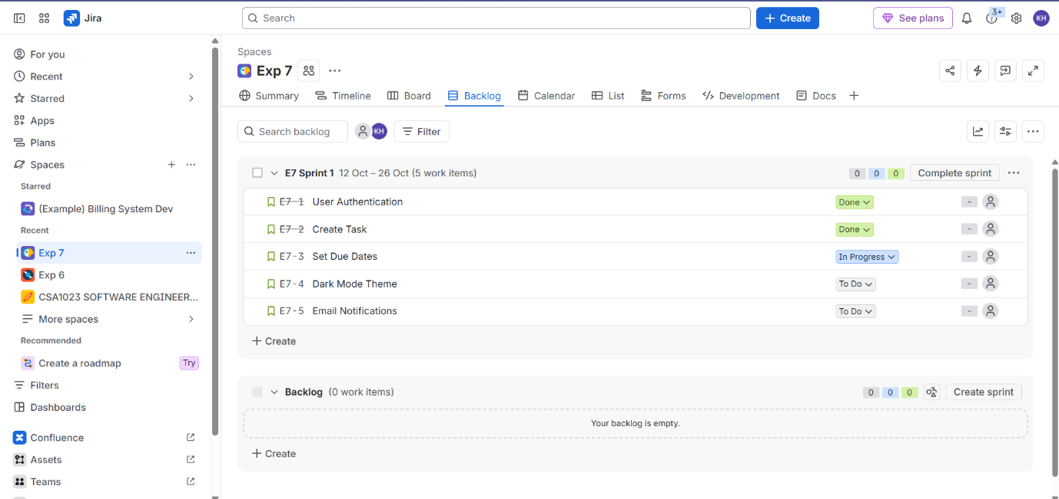
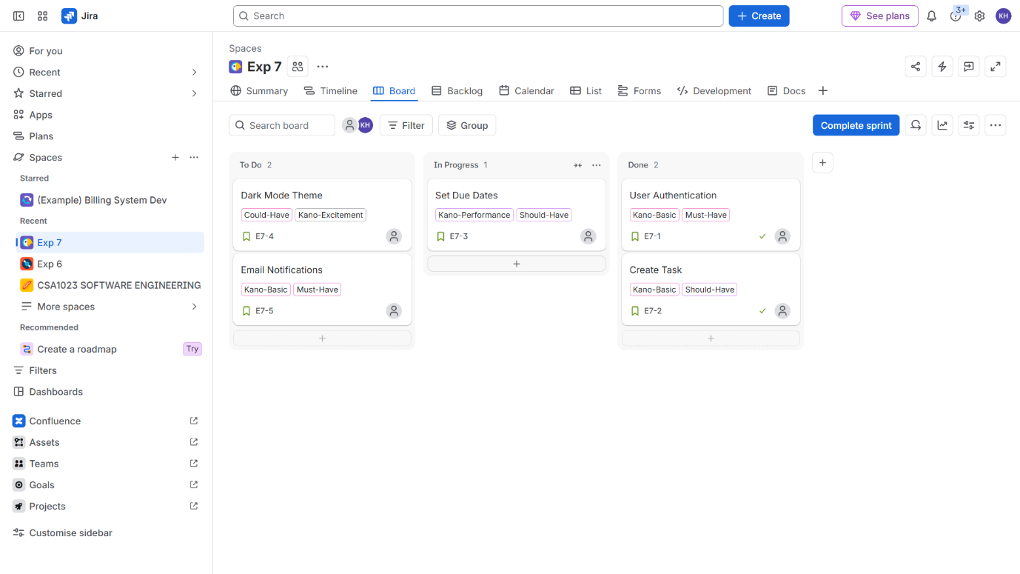
- Prioritize accordingly.
Result: Thus, The Features prioritized based on stakeholder value and satisfaction.

